Property Manager Tips
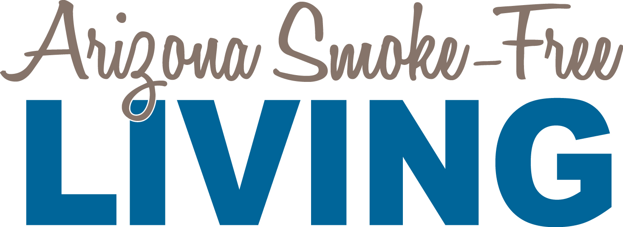

Talking Points for property managers when approached with questions about why there is a smoke-free policy:
- The smoke-free policy is our effort to provide a healthier environment for our residents and guests.

- The policy means that smoking is not allowed [anywhere on the property, or only in a designated smoking area]. Smoking includes the use of [products outlined in the policy]. Residents who choose to smoke may do so [off the property or in a designated smoking area]. The goal of the policy is to remove smoke from the community to protect all residents from the harms of secondhand smoke.

- Secondhand smoke is dangerous in any amount. Some residents have lung conditions such as asthma or chronic obstructive pulmonary disease (COPD) that are triggered by secondhand smoke. The smoke-free policy protects these residents from experiencing health-threatening episodes in their homes, allowing them to live healthily and peacefully. For more information about the dangers of secondhand smoke exposure, you can find a fact sheet on the Arizona Smoke-Free Living website (www.AzSmokeFreeLiving.org). (Note: you may also consider printing copies of the “Ten Facts About Secondhand Smoke” fact sheet to provide to interested residents.)

- Smoking indoors is a fire hazard. Removing smoking from the property [or Allowing smoking to occur only in a designated area] helps protect all residents from risk of fire in their homes. Sometimes, insurers will offer a discount on renter’s insurance if there is a smoke-free policy where you live. Ask your insurance broker for more information.

- The property management team will do its best to enforce the no-smoking rule, just as we would for any other rule. If you witness a violation of the policy, please report it immediately in writing [or by the property’s specific reporting protocol] to the property management staff.

- With the help of all residents in abiding by the no-smoking policy and informing their guests of the policy, we can have a healthy, smoke-free environment for all residents and their guests to enjoy. Your help is essential in maintaining a cleaner, safer, healthier community.

Talking Points for property managers when approached about violations of the policy:
- Thank you for notifying me about the policy violation you witnessed. Please submit a description of the violation in writing. I will look into the situation and enforce it following the protocol outlined in the policy (describe the protocol, including when and how you will follow-up with the witness).

- I will take reasonable steps to enforce the smoke-free terms of the lease. As stated in the policy, even though there is a no-smoking rule, I cannot guarantee a smoke-free environment. With all residents voluntarily in compliance with the policy, we can all enjoy a smoke-free environment.

